The 2016 Trent SBA Event 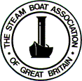 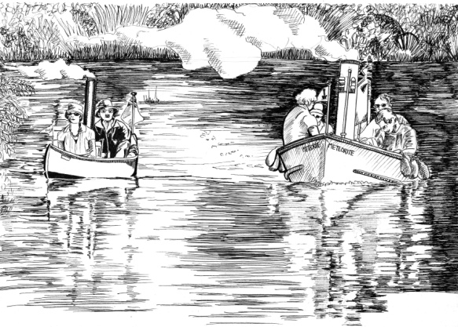

THIS YEAR IS THE 30TH S.B.A Trent Event WHAT A GOOD EXCUSE FOR A PARTY!

1st - 2nd – 3rd July 2016 @ Trent Valley Sailing Club - Trent Lock- Long Eaton NG10 2FY
For the 30th year, Trent Valley Sailing Club will again be host to Steamboaters.

The event has changed little over the years,
so as it still seems to bring smiles to our grimy faces, it won’t be much different this year.

For the two cruising days, we have a choice of 4 navigations:-
-Up the Soar to Normanton
-Down the Trent to Nottingham
-On the Erewash canal to Sandiacre
-To Shardlow on the Trent and Mersey
(with the possibility to visit Trevor Scott’s steam garden railway)

It is expected that boats will arrive on Friday, launching at either Redhill Marina or Sawley Marina.

Camping in any form is possible on the premises, and all facilities are available.

So, do clear a slot in your busy diaries, send me the completed entry form,
with a cheque made out to J.B Tilley, we look forward to meeting up again.

The event: Friday 1st
- Arrive (for most) launching at Sawley Marina* (cheapest)
Buffet at 8pm, in the 100 year old Clubhouse.

Saturday 2nd
- Communal Breakfast (8.30 - 9.300) in the Clubhouse
Off at 10 on our chosen waterway
Return in time for our banquet in the Clubhouse.
Gathering in the Club House from 7.0 eating at 8.00

Sunday 3rd
- Communal Breakfast again 8.30 - 9.30
Off 10 ish for the days steam,
Return to Trent Lock for tea, or Sawley or Redhill to pull out.

John and Françoise

PS: Currently Sawley Marina (01159 725 471) slipway is accessible 9 - 5.30 (later by some arrangement)

You will need to check in at the Chandlery to sign in and present (or purchase) your "river" licence

