From Your Chairman February 2019

Dear SBA Member
Following comments at the 2018 AGM about the cost or, more importantly, the value that we gain from having a “Reporting Accountant”, I have been canvassing opinion and consulting various similar organisations as to their best practice.
It appears that we are ‘over egging the pudding’ in that the main reason for the external audit is to assist the Treasurer in spotting any mistakes or omissions and the SBA Committee is of the view that this can be achieved without spending around £450/year on an external auditor. Your Committee has, therefore, agreed the wording of an amendment to the SBA Constitution as set out below:
“The Treasurer shall prepare an annual financial statement in a format to the satisfaction of the Committee detailing the Association’s financial situation for the preceding year. An SBA member, who shall not be a member of the Committee and who shall have been approved by the members present at the preceding AGM, will review the Treasurer’s financial statement. Any anomalies or mistakes reported by the reviewer shall be corrected by the Treasurer and the financial statement shall then be presented to the Committee for final approval before being presented to the membership at the AGM for their formal approval.”
Whilst we are polling the membership, I am also asking that you approve a minor amendment to remove a small ambiguity from Clauses 13 & 14:
Remove “provided that the decision is confirmed by a simple majority of a subsequent written referendum of all Members”
and replace it with “provided that the decision is confirmed by a simple majority of all Members who vote in a subsequent referendum.”
As with all Constitutional amendments we are required to submit this proposal to ALL members at least 21 days before the AGM which is why you are receiving this email.
In order to be adopted, the amendment must garner two thirds support from those present at the AGM and then be ratified by a simple majority of ALL members.

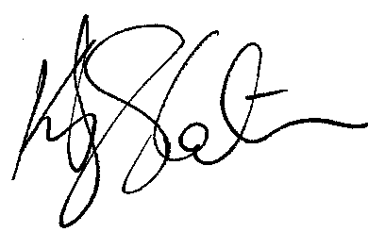
Best Regards

Kevin Slater CEng
Chairman

